

Yard & Coolstore Worker – Job Description

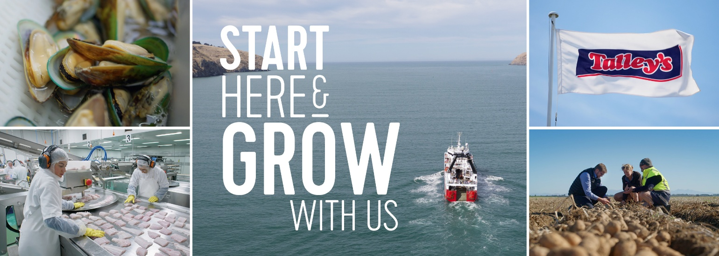

POSITION TITLE: | Yard & Coolstore Worker
BASED: | Timaru
REPORTS TO: | Supervisor, 2IC, Branch Manager
DIRECT REPORTS: | N/A
OVERALL PURPOSE: | To be part of the shared responsibility to ensure efficient loading/unloading, receiving and dispatching of all product. This must be done in accordance with the company Risk Management Program
RELATIONSHIPS | Internal | Branch Manager  2IC  Supervisors  Compliance Team  Health & Safety Co-Ordinator  Health & Safety Representatives  All Production Team Members  Freight Teams
RELATIONSHIPS | External | Freight Companies, Couriers, Skippers, Vessel Owners
DELEGATED AUTHORITY: | As per delegated authority guidelines.

KEY ACCOUNTABILITIES
Key accountabilities and responsibilities of the role | - To ensure the standard of product meets company standards.  - To ensure product is handled with care at every step of the process.  - To ensure the cold chain is maintained at every step of the process.  - Reporting to your supervisor when standards are not being met.  - Maintain a safe and clean work area  - Unloading Trucks and Vessels in a timely manner  - Rotate Stocks FIFO
General: | - All day-to-day tasks required as normal  - Cleanliness is non-negotiable
Health & Safety: | - All team members will understand and engage with the Company Health and Safety H&S Strategy, Plan and HSMS  - Be aware of and comply with the legislative requirements as defined in the HSWA 2015.  - Help establish, observe, and comply with safe work practices and equipment.  - Be involved in the development and review of procedures for identifying and managing risk/hazards in the business where required.  - Accurately report and record any events, including those relating to visitors or contractors in a timely manner in Assura.  - Use and care for safety equipment and work clothing correctly.  - Challenge unsafe behaviour by any workers in the workplace.  - Behave in a manner that does not endanger their health and safety, or the Health and Safety of others  - Halt work immediately if it would expose you (or anyone else) to a serious risk.
Other: | - From time-to-time other tasks may be requested of you to align with the changing needs of the business.  - Positively contribute to improvement efforts across the wider team  - Attend training courses, internal and/or internal

KNOWLEDGE, SKILLS AND PERSONAL QUALITIES
Qualifications and/or Experience: | - Training provided on the job
Skills and Knowledge: | - Positive attitude  - Excellent communication skills  - Solid understanding of Health and Safety regulations and practices  - Understand Food Safety Policy  - Good understanding of the company wharf manual
Personal Attributes: | - Highly organised with a strong attention to detail  - Resilient  - Pragmatic and proactive  - Ability to self-manage and use initiative  - Be a team player with a can-do attitude  - Have a desire to learn and grown your skills further

I have received, reviewed and fully understand the above job description. I further understand that I am responsible for the satisfactory execution of the essential functions described therein, under any and all conditions as described.

Name: |  | Signed:
Dated:

