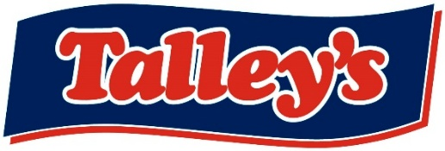

Forklift Driver – Job Description

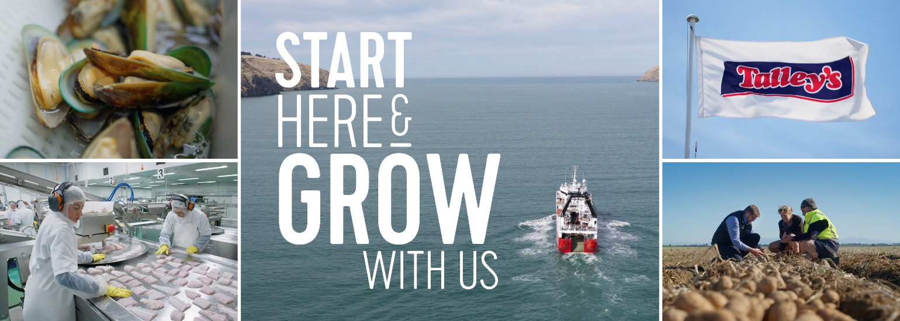

POSITION TITLE: | [JOB TITLE HERE]
BASED: | Motueka
REPORTS TO: | Manager
OVERALL PURPOSE: | responsible for operating a forklift to load, unload, move, and stack products and materials within the warehouse or production facility, ensuring accuracy and efficiency while maintaining safety protocols.
RELATIONSHIPS | Internal | Key internal relationships (eg what roles they will have most contact with)
RELATIONSHIPS | External | Key external relationships (eg what external entities they will deal with regularly)
DELEGATED AUTHORITY: | As per delegated authority guidelines.

KEY ACCOUNTABILITIES
Areas of Responsibility: |  | - Operate forklifts and other warehouse equipment safely and efficiently.  - Load and unload goods from trucks or containers.  - Move raw materials to production workstations.  - Stack and store materials in appropriate areas.  - Perform daily equipment checks and report maintenance needs.  - Maintain accurate records of inventory and shipments.  - Follow all company safety procedures and protocols.  - Assist with general warehouse duties as needed.
General: |  | - All day-to-day tasks required as normal  - Cleanliness is non-negotiable
Overlapping Duties | - Fill in for other departments when and where needed
Health & Safety: |  | - All team members will understand and engage with the Company Health and Safety H&S Strategy, Plan and HSMS  - Be aware of and comply with the legislative requirements as defined in the HSWA 2015.  - Help establish, observe, and comply with safe work practices and equipment.  - Be involved in the development and review of procedures for identifying and managing risk/hazards in the business where required.  - Accurately report and record any events, including those relating to visitors or contractors in a timely manner in Assura.  - Use and care for safety equipment and work clothing correctly.  - Challenge unsafe behaviour by any workers in the workplace.  - Behave in a manner that does not endanger their health and safety, or the Health and Safety of others  - Halt work immediately if it would expose you (or anyone else) to a serious risk.
Other: |  | - From time-to-time other tasks may be requested of you to align with the changing needs of the business.  - Positively contribute to improvement efforts across the wider team

KNOWLEDGE, SKILLS AND PERSONAL QUALITIES
Qualifications and/or Experience: | - Valid forklift operator certification/license.
Skills and Knowledge: | - Proven experience as a forklift operator (typically 1–2 years).  - Good physical condition – ability to lift up to 50 lbs and stand for long periods.  - Strong attention to detail and accuracy.  - Knowledge of warehouse data systems and inventory control.  - Ability to work in a fast-paced, team-oriented environment.  - Basic math and communication skills.
Personal Attributes: | - Highly organised  - Strong attention to detail  - Resilient  - Pragmatic and proactive  - Ability to self-manage and use initiative  - Driven for results  - Have a can-do attitude  - Be a team player  - Have a desire to learn and grown your skills further

I have received, reviewed and fully understand the above job description. I further understand that I am responsible for the satisfactory execution of the essential functions described therein, under any and all conditions as described.

Name: |  | Signed:
Dated:

