

Shift Electrician – Job Description

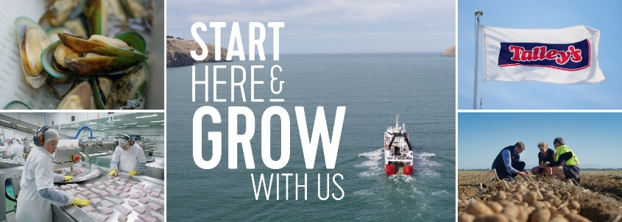

POSITION TITLE: | SHIFT ELECTRICIAN
BASED: | Vegetable Division - Ashburton
REPORTS TO: | Electrical Lead
DIRECT REPORTS: | 0
OVERALL, PURPOSE: | A Shift Engineer holds a position of responsibility to ensure the production equipment is kept in a condition that will allow full running, with as little down time as possible, in order to maintain production. To maintain relationships with other departments, and with relevant external parties. To proactively seek any opportunities for continuous improvement in all core functions. To follow up on assigned work daily and ensure it is executed safely and to the right standards, considering reliability, quality, food safety, productivity and cost. To ensure accurate feedback on all completed tasks and to identify any follow-up actions required, with an emphasis on improving plant reliability. Be a member of the operations team. Observe the responsibilities of this function, its reporting requirements, and profit responsibility.
RELATIONSHIPS | Internal | Engineering Manager  Maintenance Lead  Department Supervisors Team Leaders  Direct Reports
RELATIONSHIPS | External | Contractors  Suppliers  Original Equipment Manufacturers (OEM)
DELEGATED AUTHORITY: | As Per Delegated Authority

KEY ACCOUNTABILITIES
Areas of Responsibility: | - Receive instructions from the Maintenance Planner / Chief Engineer / Head Engineer or others as the needs of the business requires.  - Accurately maintain all documentation and records, both written and electronic  - Be a point of contact on all day-to-day maintenance issues for the production equipment and any other services equipment.  - Ensure company documented procedures and business rules are conformed to  - Take ownership of quality system, food safety and HACCP program  - Ensure all work is done with the correct work request paperwork and all information is provided  - Ensure all work is completed and reported with the correct reporting paperwork  - Compliance with AS/NZS Standards and Regulations  - Apply sound RCA and fault-finding techniques to improve plant reliability.
General: | - All day-to-day tasks required as normal.  - Cleanliness is non-negotiable.
Health & Safety &  Wellbeing: | - All team members will understand and engage with the Company Health and Safety H&S Strategy, Plan and HSMS.  - Be aware of and comply with the legislative requirements as defined in the HSWA 2015.  - Help establish, observe, and comply with safe work practices and equipment.  - Be involved in the development and review of procedures for identifying and managing risk/hazards in the business where required.  - Accurately report and record any events (notifiable events, injuries, incidents, near misses and discomfort and soreness), including those relating to visitors or contractors in a timely manner in Assura.  - Use and care for safety equipment and clothing correctly and as required whenever it is provided.  - Challenge unsafe behaviour by any workers in the workplace.  - Behave in a manner that does not endanger the health and safety of themselves or others.  - Halt work immediately if it would expose you (or anyone else) to a serious risk.  - Prioritising employee wellbeing, ensuring a supportive, balanced and inclusive environment.  - Foster a safety-first culture, utilising regular team and toolbox meetings to drive key messages and establish open communication channels.
Other: | - From time-to-time other tasks may be requested of you to align with the changing needs of the business.  - Cover in the absence of peers and direct reports as required to ensure best outcomes for the business.  - Positively contribute to improvement efforts across the wider team.

KNOWLEDGE, SKILLS AND PERSONAL QUALITIES
Qualifications and/or Experience: | - EWRB registered and have a current practising licence.  - 2 years industrial experience.  - Strong knowledge of building trades, cleaning procedures and maintenance practices.  - Solid understanding of health and safety regulations and practices.  - CMMS experience (highly advantageous).
Skills and Knowledge: | - Strong leadership and management skills.  - Computer literate with capability in email, MS Office, MS Teams, Deputy etc.  - Excellent communication skills.  - Ability to plan, organise, and prioritise tasks to meet deadlines and objectives efficiently.  - High level of attention to detail, ensuring that all quality procedures and standards are followed without compromise.
Personal Attributes: | - A professional approach to represent Talley’s Ltd in a professional manner.  - Drive to achieve results and action-orientated, work at pace.  - Sound negotiation and conflict resolution skills.  - Use their initiative and make commercial decisions as required.  Effective trouble-shooter.

KEY PERFORMANCE INDICATORS
- Timely completion of Preventative Maintenance activities to schedule.
- Breakdown.
- Downtime due to maintenance.
- Accurate job / work reporting.
- Plant Availability.

I have received, reviewed and fully understand the above job description. I further understand that I am responsible for the satisfactory execution of the essential functions described therein, under any and all conditions as described.

Name: |  | Signed:
Dated:

